Figure 1:Allowed Energy of Two Well Lattice of Depth 300eV and Varying Separation

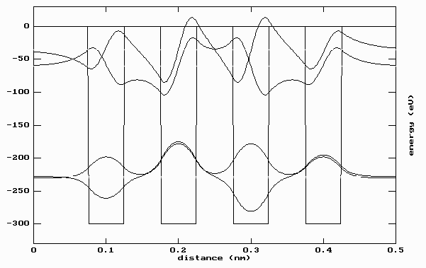

Figure :Boundary State Energies for a four-well lattice of depth 300eV, width 0.05nm and separation 0.05nm